Name: Date: Period:
Cells and Their Organelles!
Directions: Read the following statements use the statements to answer the questions below.
Part 1: Cell Membrane
The cell is the basic unit of life. All cells are surrounded by a cell membrane. Sometimes the cell membrane is also known as the plasma membrane. The cell membrane is semipermeable which means it allows some substances to pass into the cell and not other substances. The cell membrane is made of phospholipids and proteins. Plant cells have an additional layer surrounding the plasma membrane called the cell wall. The cell wall provides structure and support to plant cells.
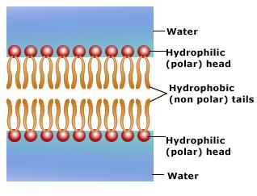
- What makes up all living things?

- What surrounds all cells?

- What does semipermeable mean?

- What 2 things make up the cell membrane?

- The cell membrane is also called the

P Membrane

- Plant cells have an extra layer surrounding their cell membrane. What is the extra layer called?

Part 2: Nucleus
The nucleus controls many of the functions of the cell. The nucleus is found in the center of the cell and has the nickname of “the brain” of the cell. The nucleus also contains DNA assembled into chromosomes. The nucleolus is found inside the nucleus. The nucleolus makes ribosomes. Ribosomes are responsible for protein synthesis, or the production of proteins. All cells, even prokaryotes, contain ribosomes. The nucleus and other organelles are surrounded by the cytoplasm. The cytoplasm is the jellylike material inside the cell.
- Where is DNA found inside the cell?

- DNA is assembled into coils called
C
- Where are organelles located?

- Do all cells need ribosomes?

- The process of making proteins is called

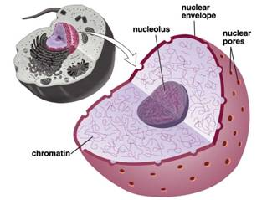

Part 3: The ERs and Golgi
The Rough Endoplasmic Reticulum (Rough ER) is a system of interconnected, membrane sacks located in the cell’s cytoplasm. The Rough ER is covered with ribosomes that gives it a rough appearance. The Rough ER is responsible for producing and transporting proteins to the Golgi Apparatus. The Smooth ER is connected to the Rough ER. The Smooth ER does NOT have ribosomes on its surface. The Smooth ER is responsible for making lipids, controlling the cell’s calcium levels, and detoxifying the cell of poisons, alcohol, and drugs. The Smooth ER will transport lipids to the Golgi Apparatus. The Golgi Apparatus modifies and packages proteins, carbohydrates, and other cell products into membrane-bound vesicles for transport from the cell.
- How is the Rough ER different from the Smooth ER? Think about the surface of both organelles…

- Proteins made by the Rough ER travel to the Golgi Apparatus. The Golgi Apparatus will M and
P proteins for transport out of the cell.
The Golgi Apparatus is the UPS delivery man. It packages and delivers!

- Give the 3 jobs of the Smooth ER:

Part 4: Plant Organelles and the Mitochondria
All energy comes from the sun. Plants use Photosynthesis to convert energy from sunlight into chemical energy (food = sugar). Only plant cells, NOT ANIMAL CELLS, can make their own food. Photosynthesis takes place in the chloroplast. Chloroplast contains chlorophyll, a pigment, to absorb sunlight. Once sunlight is absorbed by chlorophyll and other pigments, Photosynthesis can occur to produce sugar. All cells also contain fluid-filled sacs called vacuoles. The vacuole fills with food being digested and waste material that is on its way out of the cell. In the plant cells, a large central vacuole takes up most of the space in the cell. In all cells the mitochondria converts stored energy in food (glucose) into active energy known as ATP. The process of converting food energy into ATP is called Cellular Respiration.
- What is the source of ALL energy?

- What process takes place in the chloroplasts?

- What pigment traps sunlight?

- Chloroplasts are found in what type of cell(s)?

- What is produced by Photosynthesis?

- Digested food and water material is stored in what organelle?

- What process occurs in the mitochondria?

- What occurs in cellular respiration?

