Name: Date of Exam:
Cell Transport Study Guide
- Draw and label a phospholipid. Make sure to include hydrophobic, hydrophilic, polar and nonpolar.
- What is the plasmodesmata used for and what type of cell is it found?
Plasmodesmata are channels or openings between PLANT CELLS to allow material such as water to easily flow back and forth between cells.
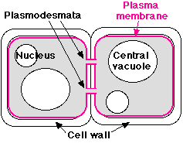
- List and describe the 3 types of junctions found in an animal cell.
- Tight Junctions – leak proof seal that protects cells by stopping environmental fluid from separating connected cells.
- Anchoring junctions – proteins that connect 2 cells together, but still allows the cells to move and transport material.
- Communication (Gap) Junction – open channels between 2 cells to allow for easy transport.
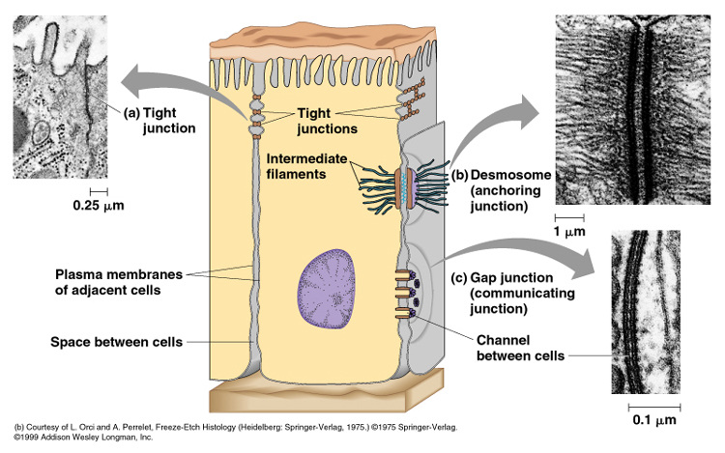
- Define diffusion – movement of molecules from a high concentration to a low concentration across the plasma (cell) membrane until the molecules reach equilibrium.
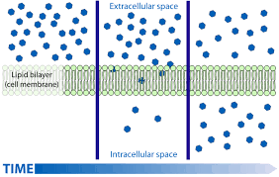

- Define concentration gradient- difference of concentration on the inside of the cell in comparison to the concentration outside of the cell.

- Define equilibrium – the concentration of molecules are balanced (equal) on both sides of the plasma membrane.

- Define osmosis – the diffusion of water. Water will move to the area where there is MORE solutes (molecules to dissolve) and LESS non-dissolving water.
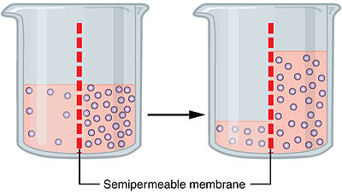
OR
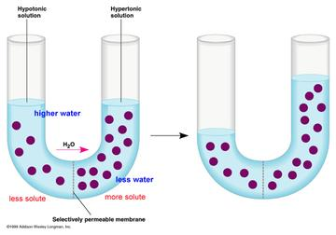

- Describe hypertonic, hypotonic, and isotonic solutions. Draw cells in each type of solution and indicate the direction the water will move (Refer to Egg Lab, Salt&Membrane, and U-Tube).
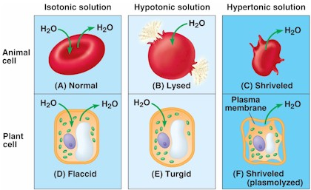
Isotonic – amount of solutes and water are equal on both sides of the plasma membrane.
Hypotonic – there are more solutes and less water on the inside of the cell than in the surrounding environment.
Hypertonic – there are less solutes and more water on the inside of the cell than in the surrounding environment.
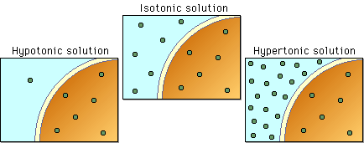

- Define facilitated diffusion- molecules unable to diffuse through the plasma membrane will move through a transport protein to reach equilibrium. The molecules will STILL move from an area of high to low concentration.
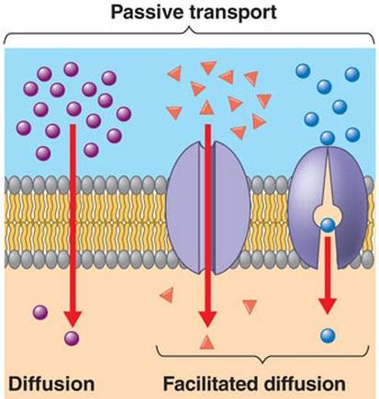

- Define active transport - requires energy in order to move molecules AGAINST the concentration gradient (from a low concentration to high concentration). Active transport requires a protein pump.
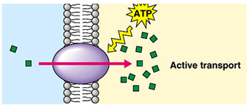

- Compare and contrast the 3 different types of transport (diffusion, facilitated diffusion, and active transport).
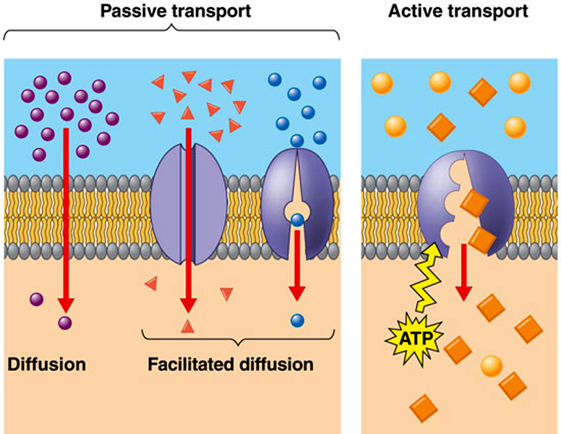
 | Diffusion | Facilitated Diffusion | Active Transport
Moves through the membrane
Moves through a transport protein
Moves from High to Low Concentration
Moves from Low to High Concentration
Requires Energy (ATP)

- What is ATP?
The molecule used for energy.
Real name: Adenosine Triphosphate
- Where is the energy located on an ATP molecule?

Energy is located between the bond of the 3rd and 2nd phosphate. When this bond is broken, energy is released.
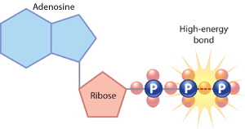

- Describe the Sodium Potassium Pump (can use drawings). Indicate which type of transport it is.
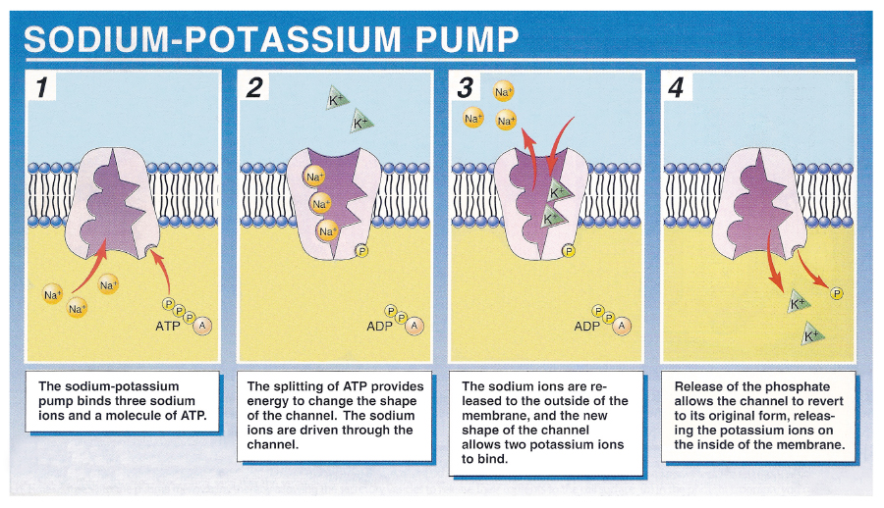

- Define exocytosis – transport of large molecules out of the cell through vesicles fusing with the cell membrane.
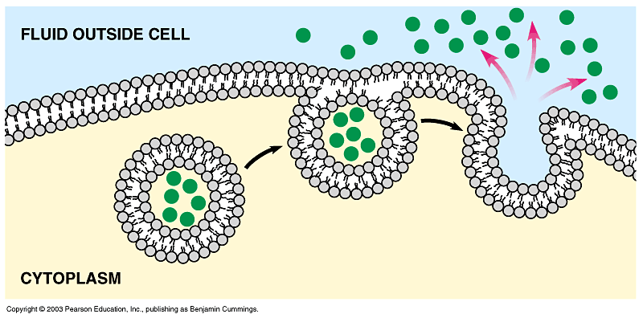
- Define phagocytosis – movement of large food molecules into the cell by the membrane extending and surrounding the food molecule to create a vesicle.
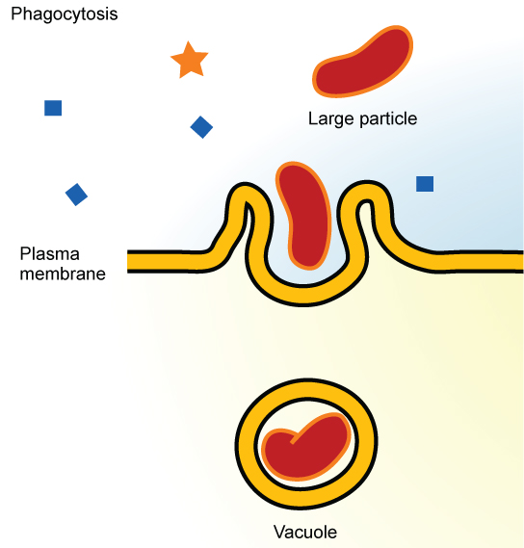

- Define pinocytosis – movement of fluids into the cell by the membrane indenting and forming a vesicle.
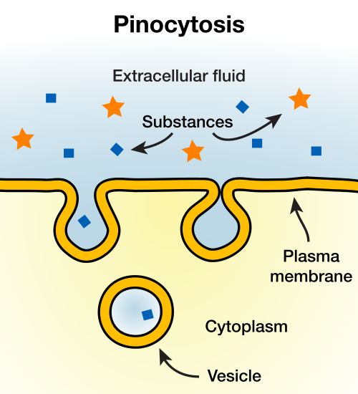

- Define receptor mediated endocytosis – the cell membrane will indent and form a vesicle to bring a specific molecule into the cell when the cell membrane binds with receptors found on a specific molecule.
- Label the following parts on the plasma membrane.
  - Proteins
  - Phospholipid
  - Cytoskeleton
  - Cholesterol
  - Glycoprotein
  - Glycolipid
Glycoprotein
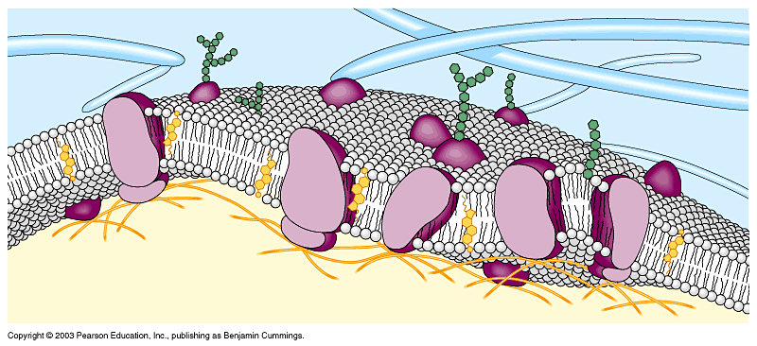
Protein
cholesterol
cytoskeleton
Phospholipid
Glycolipid

