Name: Date: Period:
Corn Dihybrid Genetics Lab
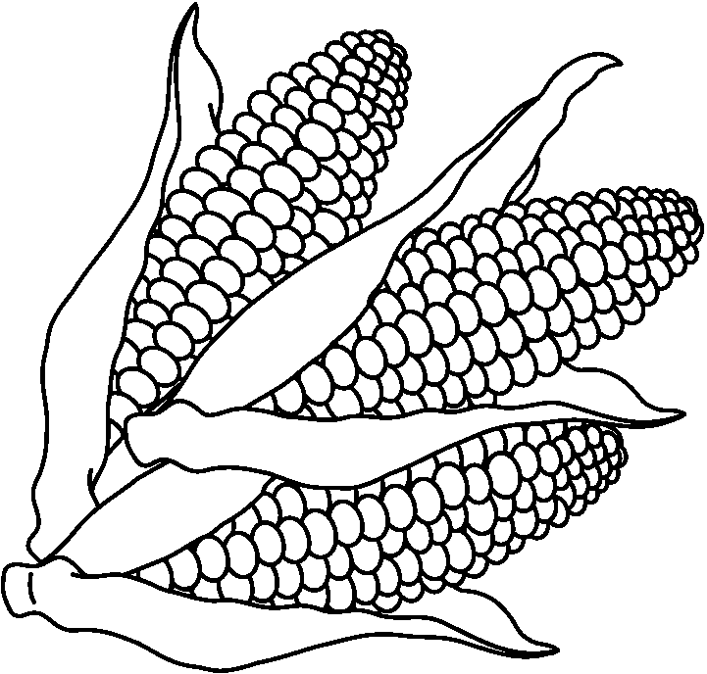
Corn have 2 recognizable traits:
Kernel Color Kernel Texture
E = Purple T = Smooth
e = Yellow t = Wrinkled
The parents (P generation) of an original cross at the seed company were EETT x eett.
The parents’ offspring (F₁ generation) were subsequently all EeTt
In this lab you will be working with the ears of corn that are the offspring of a cross between 2 F₁ generation plants. Therefore, the ears of corn in lab came from the following cross:
EeTt x EeTt
- What are the possible gamete combinations of the parent plant?

- What is the genotype of the parents??

- What is the phenotype of an EeTt?

- Complete the following dihybrid cross between 2 F₁ plants: EeTt x EeTt

Expected Phenotypic Ratio in the F₂ Generation
9 -
3 -
3 -
1 -
Procedure:
- Students can work in groups of 2.
- Count and record the number of kernels of each phenotype on an ear in the following way:
- Assign one person to be the counter and one person to be the recorder.
- Locate a section of 10 kernels by 10 kernels on your ear of corn
- The counter will call out of the phenotype of each kernel as he/she counts the row and the recorder will make the appropriate markings on the 10x10 Diagram.
- When finished, tally and record the amount of each phenotype in Table 1.
- Use the Tally Area number to determine the total amount of each phenotype for Total Ear 1 by multiplying the percentage of a specific phenotype with the total number of kernels on the ear of corn.
- Exchange data with 2 other groups who have counted a different ear of corn.
- Finish totaling all the results on Table 1.
- Answer the analysis questions.
10 x 10 Diagram
KEY
- Purple Smooth

- Purple Wrinkled

- Yellow Smooth

- Yellow Wrinkled

Table 1
 | Purple Smooth | Purple Wrinkled | Yellow Smooth | Yellow Wrinkled
Tally Area
Total Ear 1
Total Ear 2
Total Ear 3
Total for all Ears

Use the information from the Expected Phenotypic Ratio (on front page) and Table 1 to complete Table 2.
To calculate Expected Number: Multiple the percentage of the expected phenotype with the total number of kernels counted.
Table 2
 | Purple Smooth | Purple Wrinkled | Yellow Smooth | Yellow Wrinkled
Actual Number (Total for all ears)
Expected Number | 9  16  X 300  = | 3  16  X 300  = | 3  16  X 300  = | 1  16  X 300  =
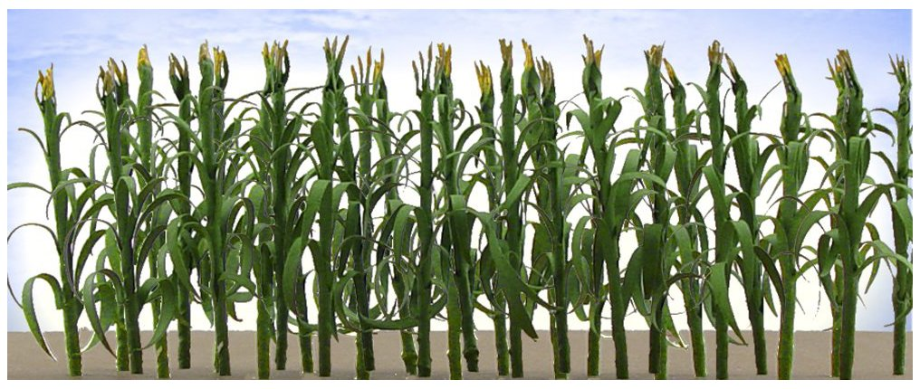

Analysis
- Which phenotypes are dominant for kernel color and texture?

- Look at Table 2. Do the numbers of the Actual Number for phenotypes appear similar to the Expected Number for phenotypes?

- List 3 factors that could cause a difference between what you actually counted and the results you expected.

- How could you work with other groups in the class to get actual counts that are closer to the expected results?

- The 2 traits we looked are (kernel color and texture) are actually on different chromosomes. Therefore, they should sort out independently of one another. In other words, the color of the kernel should not affect the texture of the kernel. If we look at one trait alone, it should sort out like a monohybrid cross (simple Punnett square).
Complete the 2 individual corsses in the Punnett squares below – one for kernel color and one for kernel texture.
Ee x Ee Tt x Tt

- What is the phenotype of corn that is EETT?

- What is the phenotype of corn that is EeTt?

- Can we tell the difference between EETT and EeTt just by looking at them?

- If the first gene is E does it matter phenotypically if the second gene is E or e?

- Using the information from the Punnett squares in #5, answer the following questions:
What fraction out of 4 offspring will appear purple (EE or Ee)

What fraction out of 4 offspring will appear smooth (TT or Tt)

- Using the information from the Punnett squares in #5, predict the expected values of the 4 different phenotypes by using Mendel’s Law of Multiplication (this only applies to genes that assort independently and are not linked).
Mendel’s Law of Multiplication:
(Probability of trait #1) x (Probability of trait #2) = Probability of combined phenotype
Ex) Trait #1 = ¼ chance of rolling tongue Trait #2 = ¼ chance of widow’s peak
(1/4) x (1/4) = 1/16 chance of offspring having a rolling tongue and widow’s peak
How many offspring will appear to be Purple AND Smooth?

- Now figure out the remaining fractions for the remaining possible phenotypes. Be sure to include your calculations!

Purple Smooth =

Purple Wrinkled =

Yellow Smooth =

Yellow Wrinkled =

- How do the numbers for each of the phenotypes that you calculated using the individual monohybrid crosses in #5 compare with the numbers for each of the phenotypes that you calculated using the dihybrid?

- Using your monohybrid crosses in #5 calculate each of the following (show your work for credit) to determine the probability. DO NOT SIMPLIFY YOUR FRACTIONS.

EeTt =

eeTt =

Eett =

EeTT =
