Name: Date: Period:
Cellular Respiration
Step 1: Glycolysis

CoA
CoA

Input:

Output:

Step 2: Citric Acid Cycle (Kreb’s Cycle)

Output:
Input:

Step 3: Electron Transport Chain – Oxidative Phosphorylation

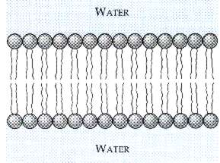
Input:

Output:

BUT WHAT IF THERE IS NO OXYGEN PRESENT?????

What type of process is this called?

