Name: _________________________________ Period: ________ Date: ________
Determining Population
This exercise will allow you to work with the concepts of population density, dispersion pattern, and sampling. The map on the back of this sheet represents a meadow on the edge of the city of Mapleton. It is surrounded by developed and farmed land but has remained relatively undisturbed. Developers plan to build a subdivision that would cover the meadow. The Mapleton Open Space Alliance would like the meadow to remain as public open land. They note the dwarf hawthorn, an uncommon shrub, is found in the meadow. It is considered a “sensitive” species by the state conservation department. The city council has asked for a construction delay until the status of the shrub is determined. You have been sent to determine the density of the hawthorn population in the meadow. Use the map of hawthorn distribution on the next page for your survey, and answer the following questions.
The area of the meadow is 16.8 hectares (a hectare is a metric unit of area equal to about 2.2 acres, so the meadow totals about 37 acres). This is too big an area to count every shrub, so you will have to look at sample plots. On the ground, this would be done with GPS and measuring tapes. You can choose random samples by merely dropping a penny on the map, drawing a circle around it, and counting the “shrubs” inside. On the scale of the map, the area covered by a U.S. penny equals 0.2 hectare.
 | 1 | 2 | 3 | 4 | 5 | 6 | 7 | 8 | 9 | 10 | Total
Number of shrubs
Sample Plot | 0.2 hectare | 0.2 | 0.2 | 0.2 | 0.2 | 0.2 | 0.2 | 0.2 | 0.2 | 0.2

1. What is the density of hawthorns in shrubs per hectare? ________

2. What is the total number of hawthorns in the meadow? ________

3. How could you make your count more accurate? Why not do this?

4. Look at the map again. What is the pattern of dispersion of the shrubs? What might cause this pattern of dispersion?

Evidence-based Conclusion
What happens to the rate of extinctions as the human population increases?
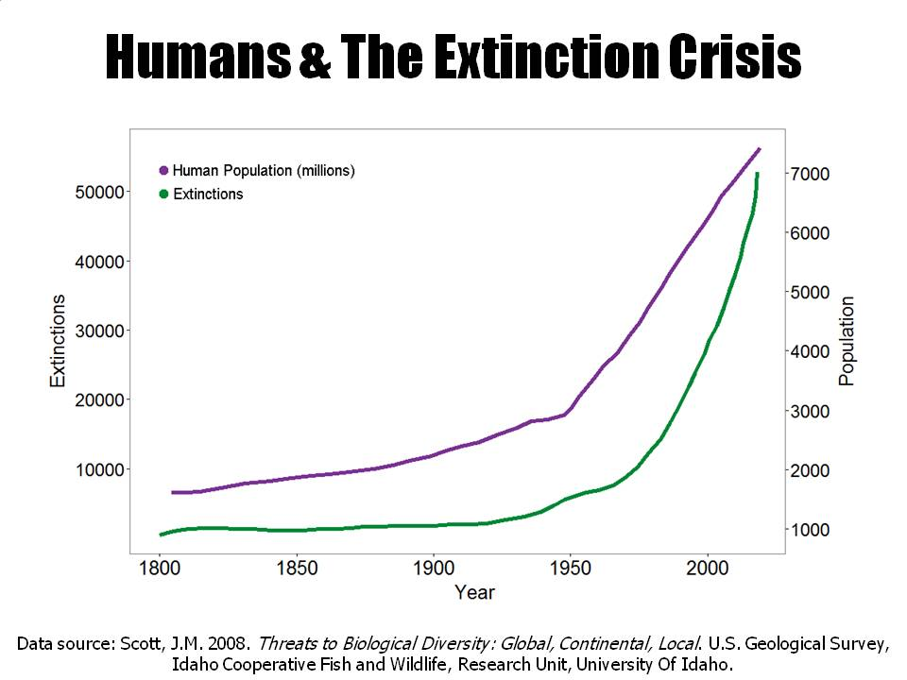

Component | Level
 | 0 | 1 | 2
Claim –  A conclusion that answers the original question. | Does not make a claim, or makes an inaccurate claim. | Makes an accurate, but incomplete claim. | Makes an accurate and complete claim.
Evidence –  Scientific data that supports the claim. The data needs to be appropriate and sufficient to support the claim | Does not provide evidence, or only provides inappropriate evidence (Evidence that does not support claim). | Provides appropriate, but insufficient evidence to support claim. May include some inappropriate evidence. | Provides appropriate and sufficient evidence to support claim.
Reasoning –  A justification that links the claim and evidence. It shows why the data counts as evidence by using appropriate and sufficient scientific principles. | Does not provide reasoning, or only provides reasoning that does not link evidence to claim. | Provides reasoning that links the claim and evidence. Repeats the evidence and/or includes some scientific principles, but not sufficient. | Provides reasoning that links evidence to claim. Includes appropriate and sufficient scientific principles

