Name: _______________________________ Date: Period:

DIHYBRID PROBLEMS

- In aliens, having 2 eyes are dominant over having one and having no hair is dominant over having hair. If a heterozygous alien (EeHh) with 2 eyes and no hair is crossed with an alien with one eye and no hair (eeHh), how many of each phenotype would you expect?

Phenotypic Ratio:

: : :
2 eyes/no hair 2 eyes/hair 1 eye/ no hair 1 eye/hair

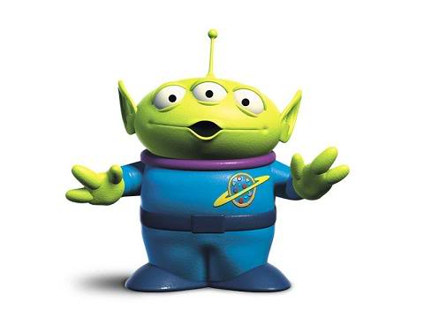

2. With the same traits as above, what phenotypes would I get and how many would expect from a cross between a one eyed alien with no hair (eeHH) and a two eyed alien with hair (Eehh)?

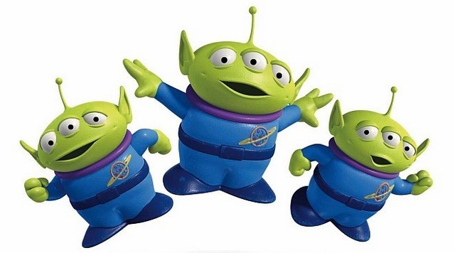
Phenotypic Ratio:

: : :
2 eyes/no hair 2 eyes/hair 1 eye/ no hair 1 eye/hair

