DEMONSTRATIONS OF OSMOSIS AND DIFFUSION

Introduction: The simplest type of passive transport is diffusion. Diffusion is the movement of molecules from an area of higher concentration to an area of lower concentration without any energy input. Diffusion is driven by the kinetic energy found in the molecules. Diffusion will eventually cause the concentration of molecules to be the same through the space the molecules occupy, causing a state of equilibrium to exist. A specific type of diffusion is osmosis, the movement of water molecules from an area of high concentration. The direction of osmosis depends on the relative concentration of the solutes on the two sides.
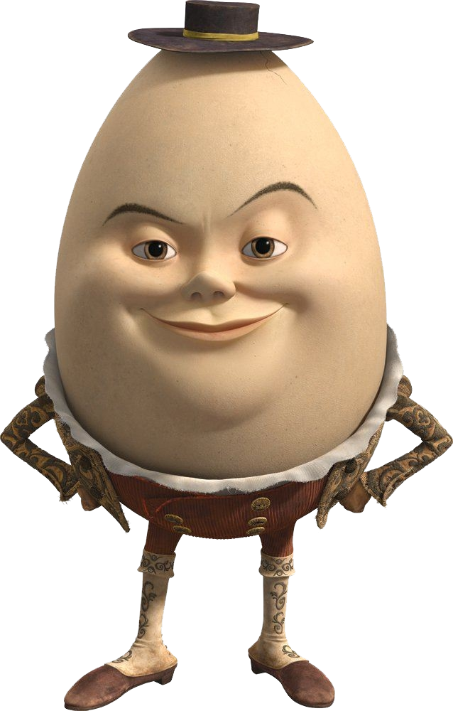

Part 1: Osmosis and the Egg

Materials
- 1 egg
- 250 mL beaker
- Spoon
- 50 mL Graduated cylinder
- Karo® Syrup
- Vinegar
- Distilled Water
- Plastic wrap
- Rubber band

Procedure
DAY 1:
1. Place a piece of paper towel on the balance and tare the balance. Measure the mass of the egg and record this data in the data table.

2. Make observations of the egg shell and record in the data table.

3. Use masking tape to label the 250 mL beaker.

4. Place the egg into the beaker. BE CAREFUL not to drop the egg into the beaker (It will break!) – tilt the beaker and place the egg in.

5. Pour 150 mL of vinegar into the beaker over the egg.

6. Cover the beaker with plastic wrap and a rubber band, and place in the designated area for 24 hours.

DAY 2:
1. Pour the vinegar into the sink and carefully remove the egg with the spoon. Gently rinse the egg in water.

2. Make observations of the egg and record in your data table. The egg shell is made of calcium carbonate and the acetic acid in the vinegar dissolves the shell to expose the membrane.

3. Place a piece of paper towel on the balance and tare the balance. Measure the mass of the egg and record in the data table.

4. Wash, rinse, and dry out your beaker.

5. Place your egg in your CLEAN beaker and add 150 mL of syrup to the egg.

6. Cover your egg with the plastic wrap and rubber band, and place in the designated area for 24 hours.

DAY 3:
1. Carefully pour out as much of the syrup solution as possible and remove the egg with the spoon.

2. Make observations of the egg and record in your data table.

3. Place a piece of paper towel on the balance and tare the balance. Measure the mass of the egg and record in the data table.

4. Wash, rinse, and dry out your beaker.

5. Place your egg in your CLEAN beaker and add 150 mL of DISTILLED water to the egg.

6. Cover your egg with the plastic wrap and rubber band, and place in the designated area for 24 hours.

DAY 4:
1. Carefully pour out the distilled water from the beaker and remove the egg with a spoon.

2. Make observations of the egg and record in your data table.

3. Place a piece of paper towel on the balance and tare the balance. Measure the mass of the egg and record in the data table.

4. Wash, rinse, and dry out your beaker. Throw the egg into the garbage.

Name: __________________________________ Date: _________ Period: _______

Osmosis and the Egg

Table 1

Solutions | Egg Mass (g) before treatment | Observations of egg before being placed in treatment | Egg Mass (g) after treatment | Observations of egg after being removed from treatment
Vinegar

Syrup

Water

Analysis:

On the diagrams below, draw in arrows to show the movement of water either going into the egg or out of the egg based on the solutions in which they were placed. Label the type of solutions they were placed in and indicate if (when compared to the egg contents) the solution is hypertonic, hypotonic or isotonic.. Next, sketch over the drawing to show the shape the egg took after sitting in the solution for 24 hours.

Day 1: Day 2: Day 3:
Solution: Solution: Solution:

Type of Solution:

Type of Solution:

Type of Solution:

Questions:

1. What cell are you using in this lab? ________

2. What was the purpose of placing the egg in vinegar?

3. What happened to the size of the egg after remaining in the vinegar (acetic acid)?

Did your egg lose or gain weight (how much?)? ______________

Was there any liquid left in the beaker? _____________

Explain why water would move into or out of the egg (include hypertonic and hypotonic)

4. What happened to the size of the egg after remaining in the corn syrup?

Did your egg lose or gain weight (how much?)? ______________

Was there any liquid left in the beaker? _____________

Explain why water would move into or out of the egg (include hypertonic and hypotonic)

5. What happened to the size of the egg after remaining in the water?

Did your egg lose or gain weight (how much?)? _______________

Explain why water would move into or out of the egg (include hypertonic and hypotonic)

6. Was the egg larger after remaining in water overnight or vinegar? ______________

Explain why there would be different results (compare the tonicities of water and vinegar)

7. Why are vegetables sprinkled with water at the supermarket? (use the terms hypertonic and hypotonic in your explanation)

8. Why would plants that are near a road that is salted in the wintertime die? (hint: What type of solution would the plant cells?)

