Name: Test Date:

DNA STRUCTURE AND FUNCTION STUDY GUIDE

1. DNA and RNA are made of what? Draw one of theses and label its part.

2. The ultimate expression of a gene is what?

3. What stage of the cell cycle does DNA replication occur? ___________________

4. Protein synthesis goes from __________ to __________ to ___________________

5. Where do each of these processes take place?

Replication – Translation –

Transcription –

6. What are the four nucleotides and tell me if they are pyrimidines or purines?

7. What are the three differences between RNA and DNA?

8. What enzymes are responsible for DNA replication? What do each do?

9. How/where does transcription begin?

10. What are the three types of RNA and what is the function of each?

11. Label the 5’ and 3’ ends of the following diagram and label the correct enzymes.
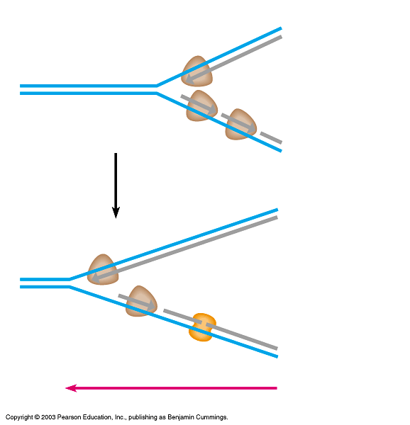

12. What happens in transcription?

13. What happens in translation?

14. If there are 90 amino acids, how many N-bases would the strand of mRNA be? ___

15. How many codons would there be? ______

16. If 30% of the bases were adenine, how many would be guanine? _____

17. What does RNA polymerase do?

18. What is a ribosome made up of?

Look at your
19. How many codons are there? ______
20. How many amino acids are there? _____
21. What are the three stop codons? __________________________
22. What amino acid is the start codon? _______________

23. What did the following scientists discover?

Griffith –

Hershey and Chase –

Chargaff –

Wilkins and Franklin –

Beadle and Tatum –

Nirenberg –

Watson and Crick –

24. What are the three types of mutations?

25. Define frame shift –

26. Define nonsense mutation –

27. Define silent mutation –

28. Define missense mutation –

29. Explain why a substitution mutation could be described as a silent mutation?

30. Complete the following table:

cDNA
DNA | GCC | TAC | ATT | CAG | GTA
mRNA codon
Anti-codon
Amino Acid

