DNA STRUCTURE AND FUNCTION STUDY GUIDE

1. DNA and RNA are made of what? Draw one of theses and label its part.

Nucleotides:
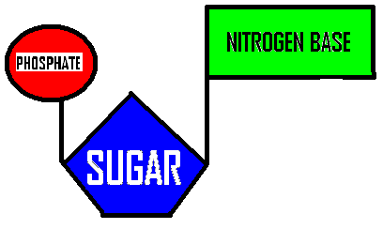

2. The ultimate expression of a gene is what?

PROTEIN SYNTHESIS

3. What stage of the cell cycle does DNA replication occur? S Phase

4. Protein synthesis goes from _DNA__ to __mRNA__ to __Amino Acids (Protein)____

5. Where do each of these processes take place?

Replication – Nucleus Translation – Ribosome/Cytoplasm

Transcription – Nucleus

6. What are the four nucleotides and tell me if they are pyrimidines or purines?

Pyrimidines – Thymine and Cytosine

Purine – Adenine and Guanine

7. What are the three differences between RNA and DNA?
DNA RNA
- Double Helix - Single Helix (single strand)
- Deoxyribose Sugar - Ribose Sugar
- Thymine base - Uracil base

8. What enzymes are responsible for DNA replication? What do each do?
DNA Helicase – unwinds the DNA
DNA Polymerase – splits the DNA strand, replicates nucleotides and proofreads the new DNA strands
DNA Ligase – connects the Okazaki fragments (new DNA fragments)

9. How does transcription begin?
Transcription begins in the nucleus at the promoter site or site of origin

10. What are the three types of RNA and what is the function of each?
Messenger RNA (mRNA) – messenger that informs the ribosome what amino acids to create

Ribosomal RNA (rRNA) – forms the ribosome along protein complex and produces the amino acids.

Transfer RNA (tRNA) – links the amino acids together to form polypeptide chains.

11. Label the 5’ and 3’ ends of the following diagram and label the correct enzymes.
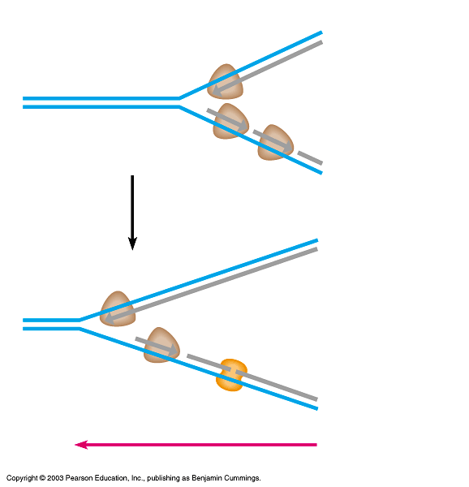
3’
5’
DNA Ligase
Okazaki Fragment
New DNA strand
DNA POLYMERASE
5’
3’

12. What happens in transcription?
In the nucleus, messenger RNA (mRNA) is created from the DNA molecule using RNA polymerase. mRNA is needed because DNA is too large to fit through the nuclear pores.

13. What happens in translation?
1. mRNA binds the ribosomal RNA. Transfer RNA (tRNA) will bind to the mRNA
2. mRNA tells the ribosome/ribosomal RNA what specific amino acids to produce.
3. tRNA catches and links the amino acids together to form a protein chain.

14. If there are 90 amino acids, how many N-bases would the strand of mRNA be? 270

15. How many codons would there be? 90

16. If 30% of the bases were adenine, how many would be guanine? 20%

17. What does RNA polymerase do?

Make the mRNA chain from DNA

18. What is a ribosome made up of?

Protein subunits and ribosomal RNA (rRNA)

19. How many codons are there? 64
20. How many amino acids are there? 20
21. What are the three stop codons? UAA, UAG, UGA
22. What amino acid is the start codon? AUG

23. What did the following scientists discover?

Griffith – discovered transformation (material from one organism can be incorporated into another organism)

Hershey and Chase – determined DNA acted as the genetic material using radioactive viruses to infect bacteria.

Chargaff – discovered “base-pairing” rule by realizing the amount of adenine always equaled the amount of thymine and the amount of guanine always equaled the amount of cytosine.

Wilkins and Franklin – capture the first image (xray) of the DNA molecule

Beadle and Tatum – “one gene – one protein” theory, that one gene coded for one protein.

Nirenberg – determined specific codons initiated specific amino acid production

Watson and Crick – determine the shape of the DNA molecule is a double helix

24. What are the three types of mutations?
1. Substitution
2. Insertion
3. Deletion

25. Define frame shift – a shift in the codon reading frame due to a deletion of insertion mutation. EFFECTS ALL PROTEIN PRODUCTION AFTER THE MUTATION

26. Explain why a substitution mutation could be described as a silent mutation?

Some proteins can result from multiple different codons. For example, Alanine (Ala) is produced from 4 different codons; GCU, GCC, GCG, and GCA. If a mutation occurred on GCU to substitute U for A causing the codon to become GCA, the protein produced will still be Alanine (Ala) and the mutation has no impact.

27. Complete the following table:

cDNA | CGG | ATG | TAA | GTC | CAT
DNA | GCC | TAC | ATT | CAG | GTA
mRNA codon | CGG | AUG | UAA | GUC | CAU
Anti-codon | GCC | UAC | AUU | CAG | GUA
Amino Acid | Arg | Met | Stop | Val | His

