Name:
Cellular Respiration Study Guide
- Define aerobic – chemical reaction occurring in the PRESENCE of oxygen

- Define anaerobic – chemical reaction occurring in the ABSENCE of oxygen

- Provide examples of activities that require energy:
Sleeping, breathing, running, ANYTHING
- How is the amount of energy measured?
Kilocalories (kcals)
- What is the chemical equation of cellular respiration?
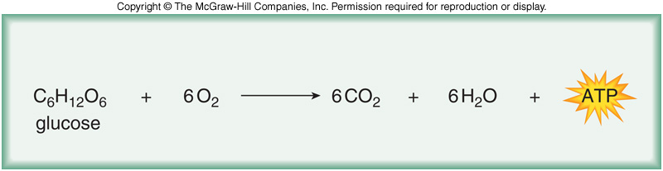
- What is being oxidized?
Glucose (C₆H₁₂O₆)
- What is being reduced?
Oxygen (O₂)
- What are the 3 steps of cellular respiration?
- Glycolysis
- Oxidation of Pyruvate
- Kreb’s Cycle (Citric Acid Cycle)
- Oxidative Phosphorylation

- Where does glycolysis occur?
Cytoplasm

- What is the input of glycolysis?
1 Glucose
2 ATP
4 ADP
2 NAD+

- What is the output of glycolysis?
2 Pyruvate
2 ADP
4 ATP
2 NADH

NET PRODUCTION OF ATP = 2

- Draw and label the steps of Glycolysis.

See flow chart and notes. YOU DO NOT NEED TO KNOW SPECIFIC NAMES OF INTERMEDIATE MOLECULES. You just need to know glucose and pyruvate plus energy and electron carriers.
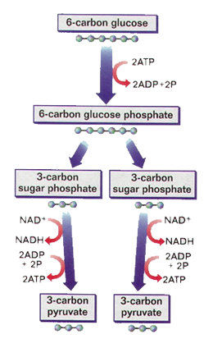

- How do the 2 pyruvate molecules prepare to enter the Kreb’s Cycle?
Oxidation of Pyruvate
- What is the released during the oxidation of pyruvate?
2 Carbon Dioxide (CO₂)
2 NADH
- Compare and contrast Substrate-level Phosphorylation and Chemiosomosis.
Substrate-Level Phosphorylation – production of ATP by an enzyme transferring a phosphate from a substrate molecule to an ADP molecule.
Chemiosomosis – production of ATP by hydrogen ions moving through a transport protein (ATP Synthase) and generating enough energy to create ATP
- What is the purpose of Glycolysis and the Kreb’s Cycle?
Glycolysis and Kreb’s Cycle produces electron carriers (NADH and FADH₂). The electron carriers donate electrons to power the Electron Transport Chain in Oxidative Phosphorylation.
- What is another name of the Kreb’s Cycle?
The Citric Acid Cycle
- Where does the Kreb’s Cycle occur?
Mitochondria

- Draw and label the steps of the Kreb’s Cycle. REMEMBER you do not need to know specific names of the molecules, but you do need to know how many carbons are at each step!
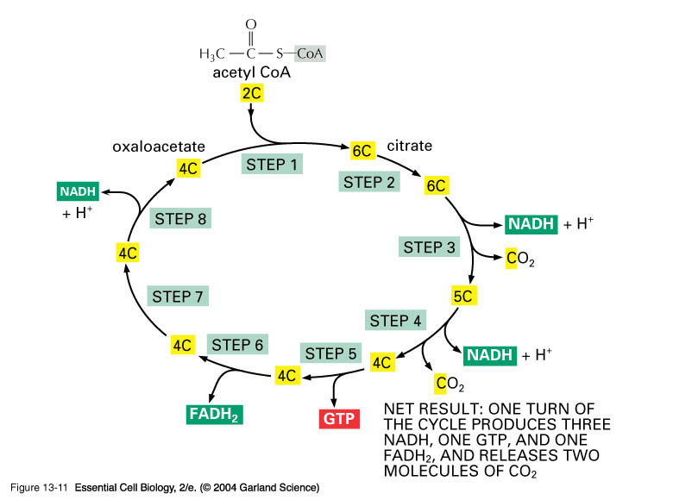

ATP
ATP

- What is the input of the Kreb’s Cycle?
Acetyl CoA
3 NAD+
1 ADP
1 FAD+

- What is the output of the Kreb’s Cycle?

3 NADH
1 ATP
1 FADH

- What are the 2 parts of Oxidation Phosphorylation?

- Electron Transport Chain
- Chemiosomosis

- How many ATP are produced in Oxidative Phosphorylation?

~ 28 ATP

- What is the final electron acceptor in Oxidative Phosphorylation?
Oxygen
- What molecules donate electrons in Oxidative Phosphorylation?
NADH and FADH₂

- What is the input of Oxidative Phosphorylation?
NADH
FADH₂
Oxygen
ADP

- What is the output of Oxidative Phosphorylation?
NAD+
FAD+
ATP
H₂O

- Why do we need to breathe oxygen?
Oxygen is the final electron acceptor. Without oxygen at the final protein complex to accept electrons, oxidative phosphorylation cannot produce the large amount of ATP.

- What would happen if the mitochondria’s membrane was permeable to hydrogen ions?
Hydrogen ions would diffuse across the membrane in order to reach equilibrium instead of traveling through ATP Synthase. Chemiosomosis will not occur and ATP will not be generated.
- When does Fermentation occur?
When oxygen is not present.

- Describe Lactic Acid Fermentation.
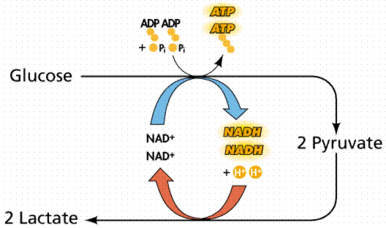
Who completes Lactic Acid Fermentation?
Animals and some bacteria
- Describe Alcohol Fermentation.
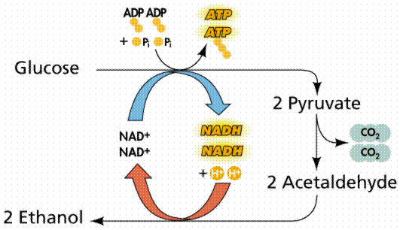
Who completes Alcohol Fermentation?
Yeast

