About Honors Biology:
Honors Biology is an advanced class regarding the biological principles of life. The topics covered were developed by the Pennsylvania’s Department of Education and included in the Biology Keystone Exam’s eligible content.
The content covered:
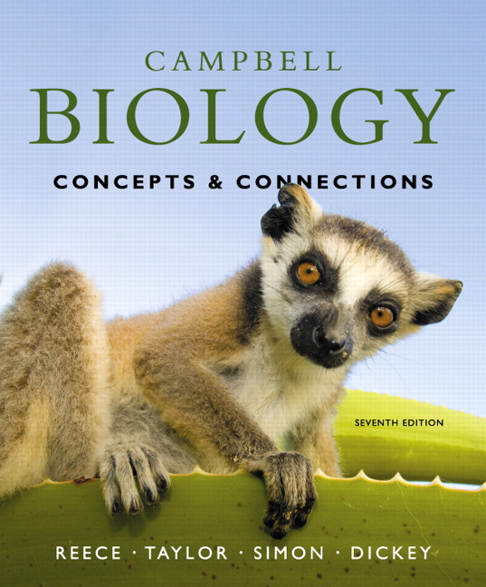
- Introduction to Biological Concepts
  - Characteristics of Life
  - Hierarchy of Life
  - Components of Experiments
- Chemical Basis of Life
  - Biochemistry
  - Properties of Water
  - Molecules of Life
- Cellular Biology
  - Components of Cells
  - Cellular Transport
- Bioenergetics
  - Photosynthesis
  - Cellular Respiration
- Cellular Reproduction
  - Mitosis
  - Meiosis
- Patterns of Inheritance
  - Mendelian Genetics
  - Nonmendelian Genetics
  - Pedigrees
- DNA to Protein Synthesis
  - DNA Replication
  - Transcription
  - Translation
- Biotechnology
  - Gene Therapy
  - Genetically Modified Organisms (GMOs)
  - Cloning
- How Populations Evolve
  - Darwin’s Theory
  - Natural Selection
  - Mechanisms of Microevolution
- Ecology
  - Community
  - Populations
  - Relationships

