Name: Date: Period:
Organic Compounds
They put the “O” in Outstanding!

Organic Compounds are any - based molecules.

The element Carbon is the backbone of life because it has electrons in its outermost electron shell.

Carbon can make covalent bonds because of its amount of electrons in its outermost electron shell.

Hydrocarbons are compounds composed of only and .

Isomers are compounds with the SAME , but DIFFERENT .

Formula for Hydrocarbons:

Type of Bonds | How Bonds Are Shown | Name Ending with Specific Bonds
Single Bond |  | Ex)
Double Bond |  | Ex)
Triple Bond |  | Ex)
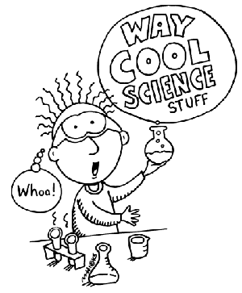

HYDROCARBONS

Hydrocarbon | Number of Carbons | Molecular Formula | Structural Formula
Methane
Ethane
Propane
Butane
Pentane
Hexane
Heptane
Octane

Nonane

Decane

Functional Groups

The unique properties of an organic compound depend NOT ONLY on the size and shape of its but also on the groups of that are attached to the carbon skeleton.

There are functional groups that are essential to the chemistry of life.

Functional Groups are polar because and
atoms exert a strong pull on the shared electrons.

Functional Group | Category | Structural Formula | Example
Hydroxyl Group

Carbonyl Group

Carbonyl Group

Carboxyl Group

Amino Group

Phosphate Group

