Name: Date: Period:
Organic Compounds
They put the “O” in Outstanding!

Organic Compounds are any CARBON - based molecules.

The element Carbon is the backbone of life because it has 4 electrons in its outermost electron shell.

Carbon can make 4 covalent bonds because of its amount of electrons in its outermost electron shell.

Hydrocarbons are compounds composed of only CARBON and HYDROGEN

Isomers are compounds with the SAME MOLECULAR FORMULA, but DIFFERENT STRUCTURAL ARRANGEMENT.

Formula for Hydrocarbons:

Type of Bonds | How Bonds Are Shown | Name Ending with Specific Bonds
Single Bond |  | - ane  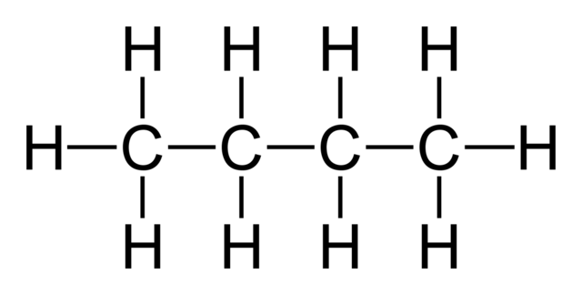  Ex) Butane
Double Bond |  | - ene  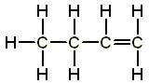  Ex) Butene
Triple Bond |  | - yne  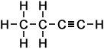  Ex) Butyne
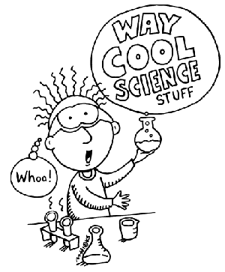

HYDROCARBONS

Hydrocarbon | Number of Carbons | Molecular Formula | Structural Formula
Methane | 1 | CH₄
Ethane | 2 | C₂H₆
Propane | 3 | C₃H₈
Butane | 4 | C₄H₁₀
Pentane | 5 | C₅H₁₂
Hexane | 6 | C₆H₁₄
Heptane | 7
Octane | 8
Nonane | 9
Decane | 10

Functional Groups

The unique properties of an organic compound depend NOT ONLY on the size and shape of its CARBON SKELETON but also on the groups of ATOMS that are attached to the carbon skeleton.

There are 5 functional groups that are essential to the chemistry of life.

Functional Groups are polar because OXYGEN and
NITROGEN atoms exert a strong pull on the shared electrons.

Functional Group | Category | Structural Formula | Example
Hydroxyl Group

Carbonyl Group

Carbonyl Group

Carboxyl Group

Amino Group

Phosphate Group

