Name: Date: Period:
Introduction to DNA
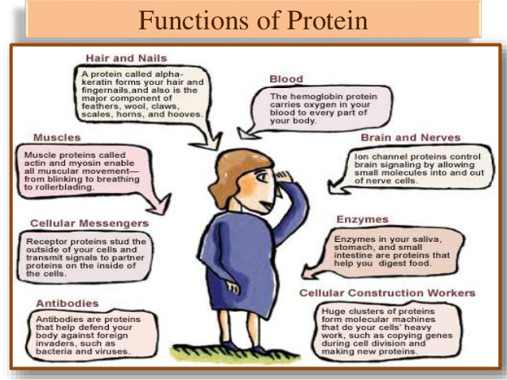
Use the picture above to identify the category and function of each type of protein.
Example: Structural - Hair and Nails
- Contractile -
- Transport -
- Signal -
- Enzymes -
- Storage -
- Defensive -

- What does DNA stand for?

- Who determined the structure of DNA?

- What is the monomer, or building blocks, of DNA?

- Label the following diagram of a nucleotide.

- Which nitrogen-bases bond with each other?
Adenine (A) bonds with
Guanine (G) bonds with
- Add the missing nitrogen-bases to the diagram below.

