Name: _____________________________Period: __________ Date: ________

THE MOLECULES OF THE CELL STUDY GUIDE

1. What two elements are in a hydrocarbon?
Hydrogen and Carbon
2. Draw a methane, ethane, propane, and butane. What are the molecular formulas for each?
Butane C₄H₁₀
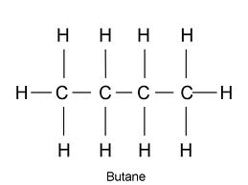
Propane C₃H₈

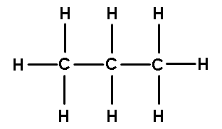
Methane CH₄
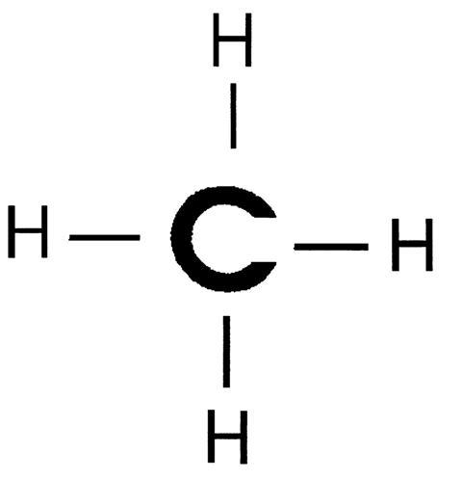

3. Draw a propene and a propyne.
Propene C₃H₆

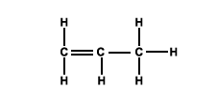
Propyne C₃H₄

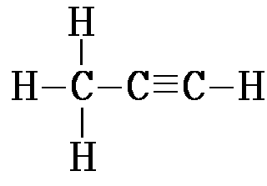

4. Draw the six functional groups.
Functional Group | Category | Structural Formula
Hydroxyl | Alcohol | -OH
Carbonyl | Aldehyde | C=O  *Placed on end of hydrocarbon chain
Carbonyl | Ketone | O  -C-  *Inserted in the middle of hydrocarbon chain
Carboxyl | Acid | O  C  OH
Amino | Amine | H  N  H
Phosphate | Phosphate | O  O P O  O⁻

5. Define monomer – smallest building block of macromolecules (polymer)

6. Define polymer –chains of monomers

7. Define dehydration synthesis – joining/linking molecules by removing a water molecule to form a bond.

8. Define hydrolysis – breaking apart molecules by adding water

9. What are the four categories of macromolecules?

Carbohydrates, lipids, proteins, nucleic acids

10. If two molecules have the same number of carbons, what could make their characteristics different?

Types of bonds (single, double, or triple) AND the types of functional groups attached.

Carbohydrates
11. What monomer makes up carbohydrates?

monosaccharides

12. What are some examples of monosaccharides? What is the general formula?

Glucose, ribose, fructose, and galactose

C_{n}H_{2n}O_{n}

13. Complete the following, also describe where each sugar is found.

Glucose + Glucose = Maltose

Glucose + Galactose = Lactose (milk)

Glucose + Fructose = Sucrose (table sugar)

14. What are the 4 different polysaccharides? Give examples of each.
1. Glycogen – storage in animals found in muscle tissues
2. Starch – plant storage found in certain vegetables
3. Cellulose – plant structure found in cell walls of plants (CORN)
4. Chitin – animal structure found in the exoskeleton of arthropods

Lipids
15. What is the most concentrated form of stored energy? FATS

16. What two monomers make up fats and how many of each?

1 – Glycerol 3 – fatty acids

17. What are two characteristics of all lipids?

Non-polar AND hydrophobic

18. What are four examples of lipids?

- Triglycerides
- Phospholipids
- Waxes
- Steroids

19. Define saturated fats and give examples – Animals fats – saturated/drenched with hydrogen. The saturated fats have the maximum amount of hydrogens. ALL SINGLE BONDS

Ex. Butter, lard

20. Define unsaturated fats and give examples – PLANT DERIVED – has less than the maximum hydrogen bonds because of the presence of at least one double bond.

Ex. Olive Oil, Canola Oil, Vegetable Oil

21. What are phospholipids for?

Cellular (plasma) membrane

22. What are waxes for?

Protection:

Plants have cuticles made of wax to protect against water loss

Animals use waxes for protection against water in the ears (ear wax).
ALSO used for pigments

23. What are steroids for?

Steroids are used for cell membrane structure and to produce sex hormones

Proteins
24. What are the 7 types of proteins?
1. Defensive
2. Transport
3. Structure
4. Signal
5. Enzymes
6. Contractile
7. Storage

25. Draw an amino acid and label the functional groups.

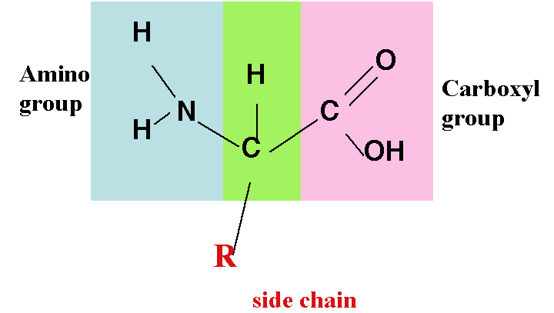

26. How many amino acids are there?

20

27. What type of bonds do amino acids form when they join? How do 2 amino acids join together?

Bond: Peptide Bonds

Amino acids are joined together by dehydration synthesis

28. Describe the four structural levels of proteins.

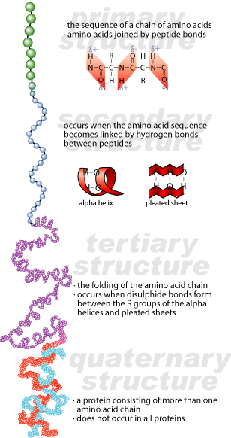

Which level shows the folding of the polypeptide chain? Secondary

What type of bonds hold them there? Hydrogen bonds

29. Define denature – damage to the protein structure that causes proteins to unravel to its primary structure

30. What are two ways to denature a protein?
Change the temperature and pH

31. What level of the structure of proteins is not denatured when it is heated?

Primary Structure

Nucleic Acids
32. What are 2 examples of nucleic acids?

DNA and RNA

33. What monomer makes up a nucleic acid? Draw one and label all parts.

Nucleotides

33. What is the function of nucleic acids?

Nucleic Acids are the instructions to create amino acid in a specific sequence to make us who we are

34. What are some differences between RNA and DNA?
RNA – single helix strand
DNA – double helix

