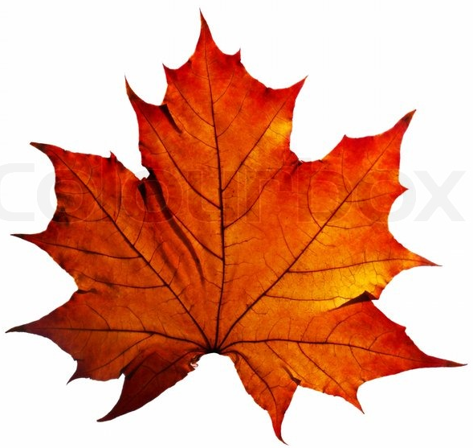
Why Do Leaves Change Color?
If you are lucky, you live in one of those parts of the world where Nature has one last fling before settling down into winter's sleep. In those lucky places, as days shorten and temperatures become crisp, the quiet green palette of summer foliage is transformed into the vivid autumn palette of reds, oranges, golds, and browns before the leaves fall off the trees. On special years, the colors are truly breathtaking.
How does autumn color happen?
For years, scientists have worked to understand the changes that happen to trees and shrubs in the autumn. Although we don't know all the details, we do know enough to explain the basics and help you to enjoy more fully Nature's multicolored autumn farewell. Three factors influence autumn leaf color-leaf pigments, length of night, and weather, but not quite in the way we think. The timing of color change and leaf fall are primarily regulated by the calendar, that is, the increasing length of night. None of the other environmental influences-temperature, rainfall, food supply, and so on-are as unvarying as the steadily increasing length of night during autumn. As days grow shorter, and nights grow longer and cooler, biochemical processes in the leaf begin to paint the landscape with Nature's autumn palette.
Where do autumn colors come from?
A color palette needs pigments, and there are three types that are involved in autumn color.
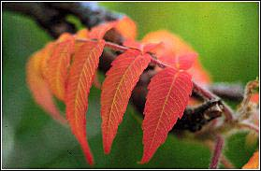 | - Chlorophyll, which gives leaves their basic green color. It is necessary for photosynthesis, the chemical reaction that enables plants to use sunlight to manufacture sugars for their food. Trees in the temperate zones store these sugars for their winter dormant period.  - Carotenoids, which produce yellow, orange, and brown colors in such things as corn, carrots, and daffodils, as well as rutabagas, buttercups, and bananas.  - Anthocyanins, which give color to such familiar things as cranberries, red apples, concord grapes, blueberries, cherries, strawberries, and plums. They are water soluble and appear in the watery liquid of leaf cells.

Both chlorophyll and carotenoids are present in the chloroplasts of leaf cells throughout the growing season. Most anthocyanins are produced in the autumn, in response to bright light and excess plant sugars within leaf cells.
During the growing season, chlorophyll is continually being produced and broken down and leaves appear green. As night length increases in the autumn, chlorophyll production slows down and then stops and eventually all the chlorophyll is destroyed. The carotenoids and anthocyanins that are present in the leaf are then unmasked and show their colors.
Certain colors are characteristic of particular species. Oaks turn red, brown, or russet; hickories, golden bronze; aspen and yellow-poplar, golden yellow; dogwood, purplish red; beech, light tan; and sourwood and black tupelo, crimson. Maples differ species by species-red maple turns brilliant scarlet; sugar maple, orange-red; and black maple, glowing yellow. Striped maple becomes almost colorless. Leaves of some species such as the elms simply shrivel up and fall, exhibiting little color other than drab brown.
The timing of the color change also varies by species. Sourwood in southern forests can become vividly colorful in late summer while all other species are still vigorously green. Oaks put on their colors long after other species have already shed their leaves. These differences in timing among species seem to be genetically inherited, for a particular species at the same latitude will show the same coloration in the cool temperatures of high mountain elevations at about the same time as it does in warmer lowlands.
How does weather affect autumn color?
The amount and brilliance of the colors that develop in any particular autumn season are related to weather conditions that occur before and during the time the chlorophyll in the leaves is dwindling. Temperature and moisture are the main influences.
A succession of warm, sunny days and cool, crisp but not freezing nights seems to bring about the most spectacular color displays. During these days, lots of sugars are produced in the leaf but the cool nights and the gradual closing of veins going into the leaf prevent these sugars from moving out. These conditions-lots of sugar and lots of light-spur production of the brilliant anthocyanin pigments, which tint reds, purples, and crimson. Because carotenoids are always present in leaves, the yellow and gold colors remain fairly constant from year to year.
The amount of moisture in the soil also affects autumn colors. Like the weather, soil moisture varies greatly from year to year. The countless combinations of these two highly variable factors assure that no two autumns can be exactly alike. A late spring, or a severe summer drought, can delay the onset of fall color by a few weeks. A warm period during fall will also lower the intensity of autumn colors. A warm wet spring, favorable summer weather, and warm sunny fall days with cool nights should produce the most brilliant autumn colors.
What triggers leaf fall?
In early autumn, in response to the shortening days and declining intensity of sunlight, leaves begin the processes leading up to their fall. The veins that carry fluids into and out of the leaf gradually close off as a layer of cells forms at the base of each leaf. These clogged veins trap sugars in the leaf and

promote production of anthocyanins. Once this separation layer is complete and the connecting tissues are sealed off, the leaf is ready to fall.
What does all this do for the tree?
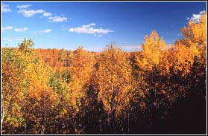
Winter is a certainty that all vegetation in the temperate zones must face each year. Perennial plants, including trees, must have some sort of protection to survive freezing temperatures and other harsh wintertime influences. Stems, twigs, and buds are equipped to survive extreme cold so that they can reawaken when spring heralds the start of another growing season. Tender leaf tissues, however, would freeze in winter, so plants must either toughen up and protect their leaves or dispose of them.
The evergreens-pines, spruces, cedars, firs, and so on-are able to survive winter because they have toughened up. Their needle-like or scale-like foliage is covered with a heavy wax coating and the fluid inside their cells contains substances that resist freezing. Thus the foliage of evergreens can safely withstand all but the severest winter conditions, such as those in the Arctic. Evergreen needles survive for some years but eventually fall because of old age.
The leaves of broadleaved plants, on the other hand, are tender and vulnerable to damage. These leaves are typically broad and thin and are not protected by any thick coverings. The fluid in cells of these leaves is usually a thin, watery sap that freezes readily. This means that the cells could not survive winter where temperatures fall below freezing. Tissues unable to overwinter must be sealed off and shed to ensure the plant's continued survival. Thus leaf fall precedes each winter in the temperate zones.
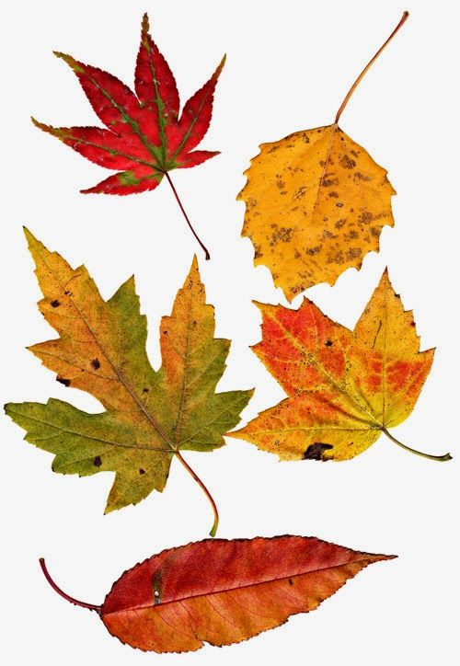 | What happens to all those fallen leaves?  Needles and leaves that fall are not wasted. They decompose and restock the soil with nutrients and make up part of the spongy humus layer of the forest floor that absorbs and holds rainfall. Fallen leaves also become food for numerous soil organisms vital to the forest ecosystem.  It is quite easy to see the benefit to the tree of its annual leaf fall, but the advantage to the entire forest is more subtle. It could well be that the forest could no more survive without its annual replenishment from leaves than the individual tree could survive without shedding these leaves. The many beautiful interrelationships in the forest community leave us with myriad fascinating puzzles still to solve.

