Name: Date: Period:
PHOTOSYNTHESIS OVERVIEW
STEP 1: Light Reaction
Occurs:

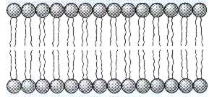
Output:
Input:

STEP 2: Dark Reaction
Occurs:
Output:
Input:
2x

Write the chemical equation for Photosynthesis:

Analysis Questions:
Indicate if each phrase describes part of the light reaction (L) or the dark reaction (D).
______1. Occurs in the stroma
______2. Occurs on the thylakoid
______3. Requires light
______4. Carbon dioxide fixation
______5. Runs twice to produce glucose
______6. Splits water to replace lost electrons
______7. Reduces ADP and NADP+
______8. Oxidizes ATP and NADPH
______9. Reduces CO₂
______10. Oxidizes H₂O

