Name: Date: Period:
Photosynthesis Study Guide
- What is the source of all energy?

- Define pigments –

- How does light travel?

- What wavelength size has the MOST energy?

- Complete the following table.

Pigments | Colors Absorbed | Colors Reflected
Chlorophyll A
Chlorophyll B
Carotenoid

- Why do plants have more than one pigment?

- What organelle is responsible for photosynthesis?

- What is the chemical reaction of photosynthesis?

- Define reduction –

- Define oxidation –

- Label the following image.

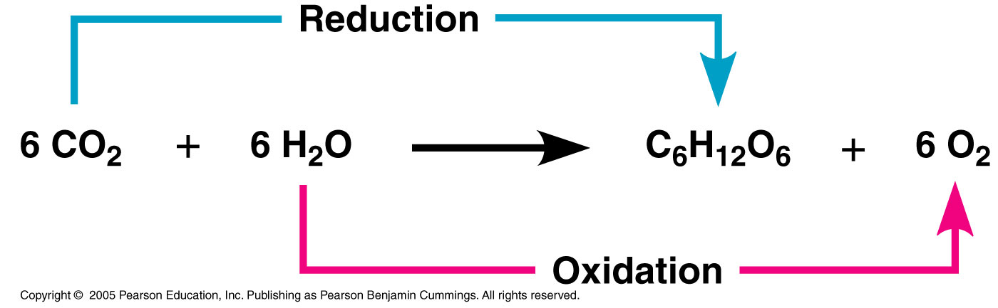

- Where does the light reaction occur?

- What is the purpose of the light reaction?

- Label the following diagram and make sure you can answer questions based on this process.
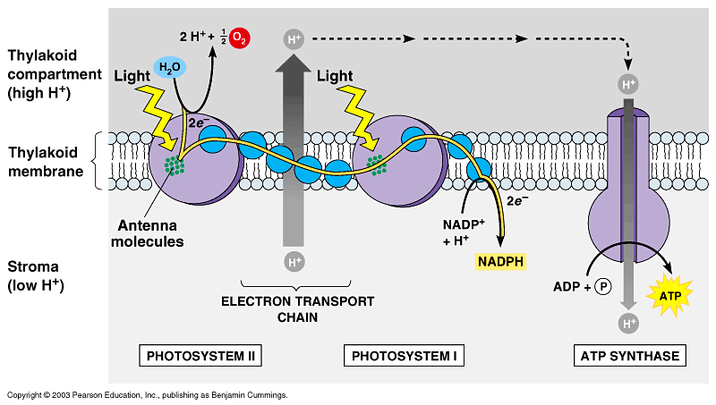

OUTPUT:
INPUT:

- What products of the light reaction are needed for the dark reaction (Calvin Cycle)?

- Where does the dark reaction (Calvin Cycle) occur?

- What is the purpose of the dark reaction (Calvin Cycle)?

- Label the following image and be able to answer questions based on this process.
INPUT:

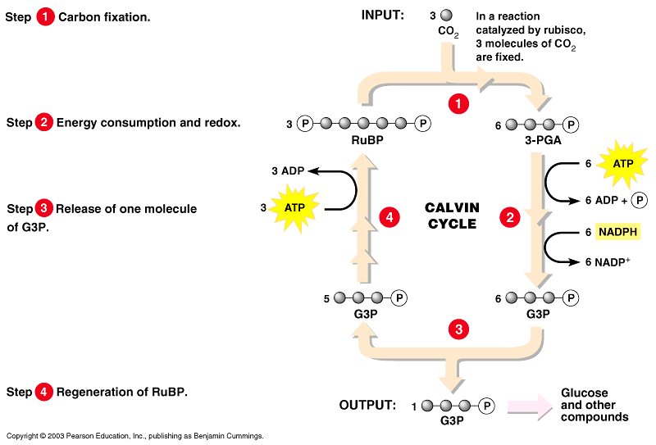

OUTPUT:

