Name: Date: Period:
Photosynthesis Study Guide
- What is the source of all energy?
SUNLIGHT
- Define pigments – Molecules that absorb light

- How does light travel?
In waves. We use the term wavelengths (nm) to describe the size of light
- What wavelength size has the MOST energy?

The smaller the wavelength the MORE energy the light has.

- Complete the following table.

Pigments | Colors Absorbed | Colors Reflected
Chlorophyll A
Chlorophyll B
Carotenoid

- Why do plants have more than one pigment?
Plants have more than one pigment to ensure the maximum amount of light is absorbed. Each pigment absorbs different type of light. Plants need light in order to produce sugar (food).
- What organelle is responsible for photosynthesis?
Chloroplast
- What is the chemical reaction of photosynthesis?
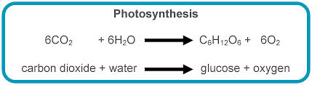

- Define reduction – the loss of positivity. Reduction is the GAINING of electrons (GER)

- Define oxidation – the gaining of positivity. Oxidation is the LOSS of electrons (LEO).

- Label the following image.

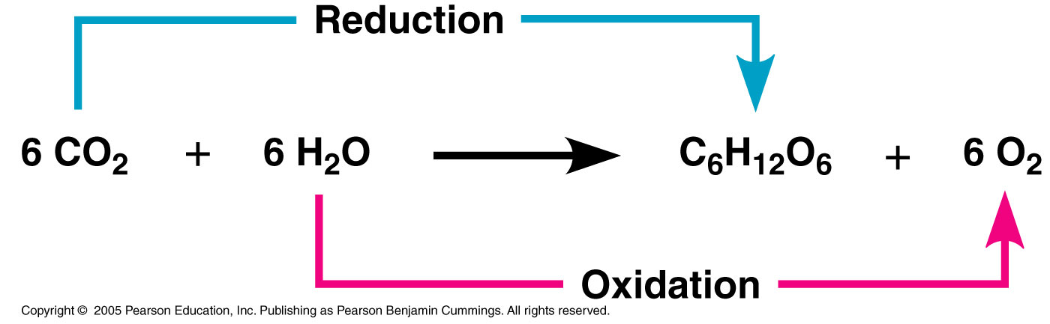

- Where does the light reaction occur?
Thylakoid Membrane

- What is the purpose of the light reaction?
To produce ATP and NADPH that will be used to fuel the Calvin Cycle.

- Label the following diagram and make sure you can answer questions based on this process.
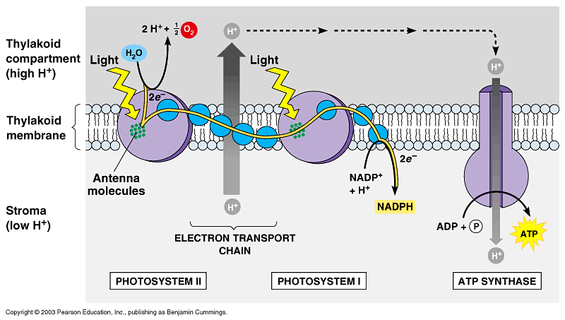

OUTPUT:
- Oxygen
- NADPH
- ATP
INPUT:
- Water
- Light
- NADP+
- ADP + P

- What products of the light reaction are needed for the dark reaction (Calvin Cycle)?
NADPH and ATP

- Where does the dark reaction (Calvin Cycle) occur?
Stroma

- What is the purpose of the dark reaction (Calvin Cycle)?
Produce Sugar

- Label the following image and be able to answer questions based on this process.
INPUT:
- 3 CO₂ (Carbon Dioxide)
- 9 ATP
- 6 NADPH
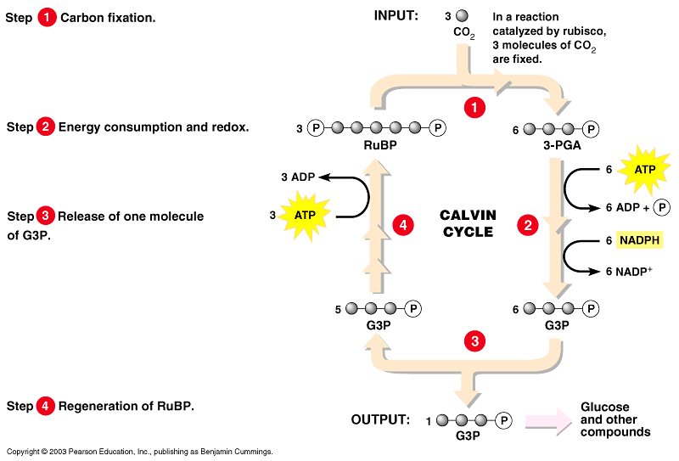

OUTPUT:
- A 3 Carbon Sugar (G3P)
- 9 ADP +P
- 6 NADP+

