Name: Date: Period:
Photosynthesis and Light Absorption by Pigments
Different pigments are more efficient at absorbing light at different wavelengths. In this exercise you will graph the individual absorption spectrum for chlorophyll a, chlorophyll b and carotene and compare them. The wavelengths and amount of absorption are listed in the table below.

There are three basic classes of pigments.
Chlorophylls are greenish pigments which contain a porphyrin ring. This is a stable ring-shaped molecule around which electrons are free to migrate. Because the electrons move freely, the ring has the potential to gain or lose electrons easily, and thus the potential to provide energized electrons to other molecules. This is the fundamental process by which chlorophyll "captures" the energy of sunlight. There are several kinds of chlorophyll, the most important being chlorophyll "a". This is the molecule which makes photosynthesis possible, by passing its energized electrons on to molecules which will manufacture sugars. All plants, algae, and cyanobacteria which photosynthesize contain chlorophyll "a". A second kind of chlorophyll is chlorophyll "b", which occurs only in "green algae" and in the plants. A third form of chlorophyll which is common is (not surprisingly) called chlorophyll "c", and is found only in the photosynthetic members of the Chromista (diatoms to giant kelps) as well as the dinoflagellates (microscopic algae). The differences between the chlorophylls of these major groups was one of the first clues that they were not as closely related as previously thought.
Carotenoids are usually red, orange, or yellow pigments, and include the familiar compound carotene, which gives carrots their color. These compounds are composed of two small six-carbon rings connected by a "chain" of carbon atoms. As a result, they do not dissolve in water, and must be attached to membranes within the cell. Carotenoids cannot transfer sunlight energy directly to the photosynthetic pathway, but must pass their absorbed energy to chlorophyll. For this reason, they are called accessory pigments. One very visible accessory pigment is fucoxanthin the brown pigment which colors kelps and other brown algae as well as the diatoms.
Phycobilins are water-soluble pigments, and are therefore found in the cytoplasm, or in the stroma of the chloroplast. They occur only in Cyanobacteria and Rhodophyta. One phycobilin is the bluish pigment phycocyanin, which gives the Cyanobacteria their name. A second phycobilin is the reddish pigment phycoerythrin, which gives the red algae their common name.

Instructions:
- Construct a graph that represents the absorption spectrum for each individual pigment.
- Use a different color for each pigment ( blue-green for chlorophyll a, yellow green for chlorophyll b, orange for carotene)
- The wavelength (in nm) will go on the X axis, while % absorption will go on the Y axis ( 0% -100%)
- Color in the spectrum of light (entire graph) to represent the various colors and their wavelengths as follows:
Violet: 380 – 440nm
Blue: 440 – 500nm
Green: 500 – 550nm
Yellow: 550 – 630 nm
Orange: 630 – 670 nm
Red: 670 – 700 nm
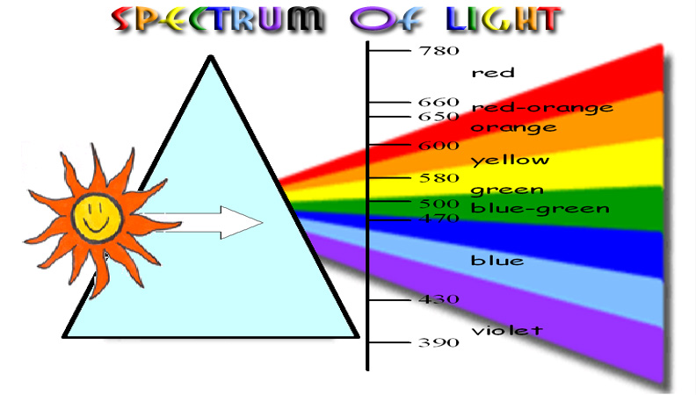

- Answer the questions that follow in the analysis section

Data Table:
Wavelength (nm) | Chlorophyll a | Chlorophyll b | Carotene
400 | 12 | 5 | 20
420 | 32 | 28 | 64
440 | 61 | 54 | 38
460 | 48 | 85 | 62
480 | 14 | 41 | 24
500 | 10 | 10 | 5
520 | 2 | 5 | 2
540 | 1 | 5 | 0
560 | 2 | 4 | 0
580 | 4 | 5 | 0
600 | 5 | 12 | 0
620 | 14 | 28 | 0
640 | 30 | 10 | 0
660 | 44 | 2 | 0
680 | 20 | 0 | 0
700 | 0 | 0 | 0

