**PROTEINS**

Carboxyl Group

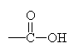

Joined by:

Dehydration Synthesis

Example:

Aspartame = Apartic Acid + Phenylalanine

Categories:

1. Enzyme

-act as catalyst

1. Transport

-Ex. carries oxygen to body tissues

1. Contractile

-main component components of muscle and skin

1. Defense

-defends body against disease

1. Structure

-spiderlike, hair

1. Signal

-hormones that regulates function

1. Storage

-present in seeds and embryos

*POLYPEPTIDE*

Consist of

3+ Amino Acids

*AMINO ACIDS*

Building Block (*monomer)* of proteins

*DIPEPTIDES*

Consist of

2 Amino Acids

Linked with:

Peptide Bonds

20 Amino Acids

This many kinds

R Group – varies from amino acid to amino acid

Hydrocarbon

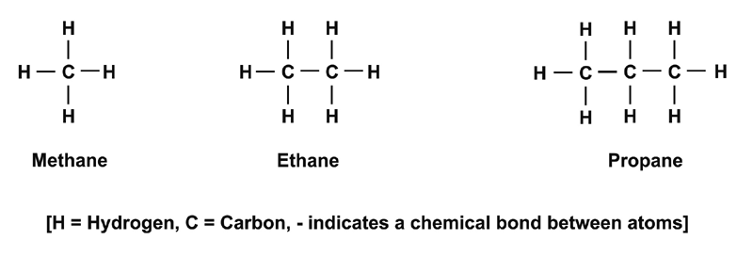

Amino Group

https://encrypted-tbn0.gstatic.com/images?q=tbn:ANd9GcTtWfpKSubXOnuuciJLdcdgZl6j-lvbqpRPpFkwNP6ZjLAPrttsMg

Contain four parts

Broken down by:

Hydrolysis