Name: Date: Period:
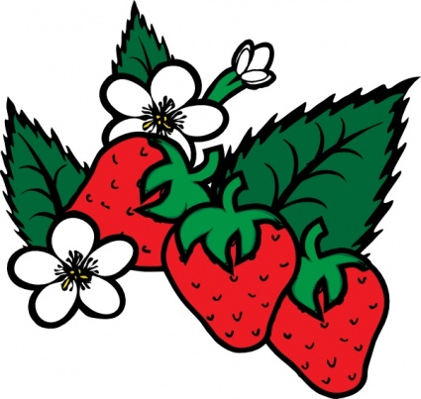
Strawberry Extraction Lab
“Every human, we all have different genetic backgrounds, we all have lived separate lives. But our genomes are greater than 99 percent similar.” — Allan Jones

Introduction:
The long, thick fibers of DNA store the information for the functioning of the chemistry of life. DNA is present in EVERY CELL of plants and animals. The DNA formed in strawberry cells can be extracted using common, everyday materials. We will use an extraction buffer containing salt, to break up protein chains that bind around the nucleic acids. We will use dish soap to dissolve the phospholipid bilayer (cell membrane) as well as the nuclear membrane. This extraction buffer will provide us access to the DNA inside the cells.
Pre-lab Questions:
- Where is DNA found in the cell (list specific organelles)?

- Why must we dissolve the nuclear membrane in order to access the DNA?

- What is the central dogma of biology?
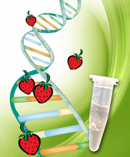

Materials:
- Ziploc Bag
- 1 strawberry
- 10mL DNA extraction buffer
- Cheesecloth or filter paper
- 10mL graduated cylinder
- Funnel
- 50mL test tube
- Glass stirring rod
- 20mL ethanol
Procedures:
- Place one strawberry in a Ziploc bag.
- Smash up the strawberry in the Ziploc bag using your fist and fingers for 2 minutes. DO NOT BREAK THE BAG!
- Measure 10mL of extraction buffer using the graduated cylinder.
- Add the 10mL extraction buffer to the Ziploc bag.
- Mush/kneed the strawberry in the Ziploc bag for 1 more minute.
- Place your funnel in the test tube (reference the diagram to the right)
- Place the cheese cloth or filter paper on top of the funnel (reference the diagram to the right)
- Pour the strawberry solution from the Ziploc bag into the filtration system you have just assembled. Let the solution drip directly into your test tube.
- Slowly pour cold ethanol into the tube. Make observations. Draw and label your observations on Figure 1.
- Remove the funnel and discard the cheese cloth/filter paper.
- Dip the glass rod into the test tube where the strawberry solution and the ethanol layers come into contact with each other. Make observations as the DNA strands collect and twirl around the glass rod.
Figure 1: Draw your observations of the strawberry solution AFTER you add the cold ethanol. Make sure to label each layer of solution and any other material
Diagram 1: Filtration System
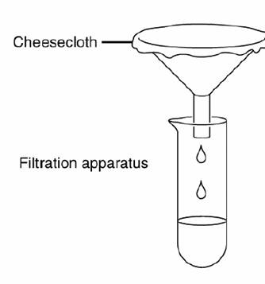
Cheesecloth or filter paper

Test Tube

Analysis Questions:
- What does DNA look like?

- A person cannot see a single cotton thread four classrooms away, but if you wound thousands of threads together into a rope, it would be visible at the same distance. How is this statement an analogy to our DNA extraction?

- Is DNA found in all living or once living cells?

- Since the strawberries were once living and we extracted DNA from them, what does this mean about the foods you eat?

- Can our foods be subject to mutations and mutagens just like our cells?

