Name: Date: Period:
How Food Chains Affect Population Size
Wolf

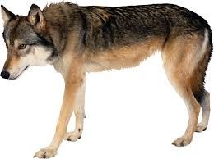
Deer
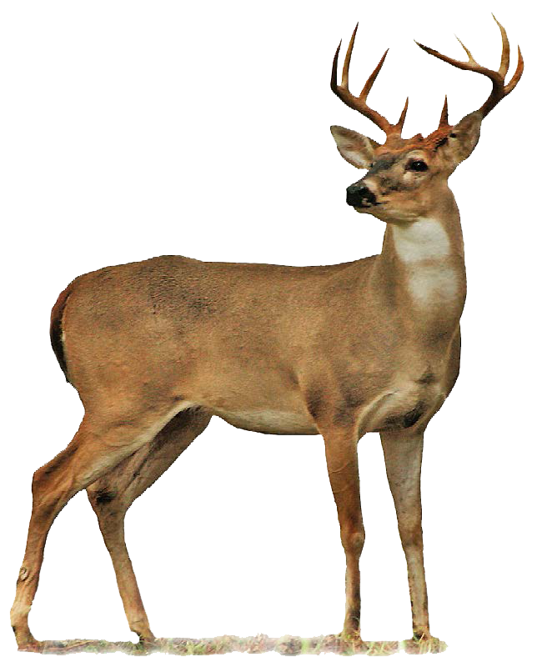
Grass
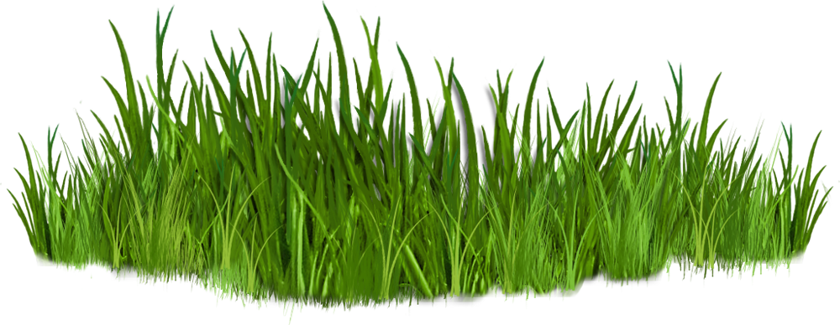
Sun

Introduction:
In 1970 the deer population of an island forest reserve about 518 square kilometers in size was about 2000 animals. Although the island had excellent vegetation for feeding, the food supply obviously had limits. Thus the forest management personnel feared that overgrazing might lead to mass starvation. Since the area was too remote for hunters, the wildlife service decided to bring in natural predators to control the deer population. It was hoped that natural predation would keep the deer population from becoming too large and also increase the deer quality (or health), as predators often eliminate the weaker members of the herd. In 1971, ten wolves were flown into the island.
The results of this program are shown in the following table. The Population Change is the number of deer born minus the number of deer that died during that year.
- Fill out the last column for each year (the first has been calculated for you).
Year | Wolf Population | Deer Population | Deer Offspring | Predation | Starvation | Deer Population Change
1971 | 10 | 2,000 | 800 | 400 | 100 | +300
1972 | 12 | 2,300 | 920 | 480 | 240
1973 | 16 | 2,500 | 1,000 | 640 | 500
1974 | 22 | 2,360 | 944 | 880 | 180
1975 | 28 | 2,224 | 996 | 1,120 | 26
1976 | 24 | 2,094 | 836 | 960 | 2
1977 | 21 | 1,968 | 788 | 840 | 0
1978 | 18 | 1,916 | 766 | 720 | 0
1979 | 19 | 1,952 | 780 | 760 | 0
1980 | 19 | 1,972 | 790 | 760 | 0

- Graph the deer and wolf populations on the graph below. Use one color to show deer populations and another color to show wolf populations.
Title:
Key
Deer:

Wolves:
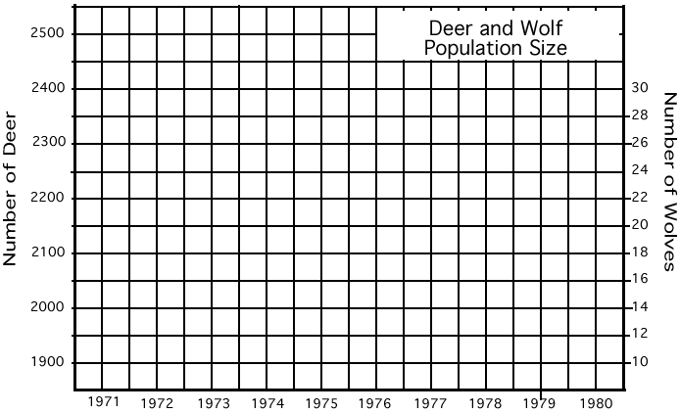

Year

- Describe what happened to the deer and wolf populations between 1971 and 1980.

- What do you think would have happened to the deer on the island had wolves NOT been introduced?

- Most biology textbooks describe that predators and prey exist in a balance. This "balance of nature" hypothesis has been criticized by some scientists because it suggests a relationship between predators and prey that is good and necessary. Some scientists believe it is better for deer to die from predators than to die from starvation while other scientists believe it is better for the deer if their population increases even if starvation kills some deer.
What is your opinion of the balance of nature hypothesis?
Would the deer on the island be better off, worse off, or about the same without the wolves. Defend your position.

